**Sprint 1 Plan**

**Heading**:

Product Name: BeatBox

Sprint Completion Date: July 9th, 2023

Revision Number: 1

Revision Date: July 3rd, 2023

**Goal:** Ensure beat creation using a default kick drum can be played and stopped with respective play and stop buttons, sped up or slowed down using the tempo button, and notes in the grid can be toggled on or off for playback.

**Task Listing and Initial Assignments:**

**1. Play Button and Stop Button**: As a musician, I want to make a drum beat using one instrument channel and play it back, so I can make a basic rhythm. (Priority: High) (Story Points: 8)

**Tasks:**

1. Create instrument channel button and 8 note buttons (3 hours)
2. Create play and stop buttons (1 hour)
3. Give the instrument channel a default sound (a kick drum) (2 hours)
4. Allow note buttons to be toggled on or off (1 hour)
5. Hitting the play button plays the drum pattern at 120 bpm and hitting the stop button stops it (4 hours)
6. A note button will flash white during playback (2 hours)

**2. Instrument Channel Play Button**: As a musician, I want to play an instrument channel’s sound so that I can hear the sample being used. (Priority: High) (Story Points: 3)

**Tasks:**

1. Make a small play button on the instrument channel that plays the default sound (3 hours)

**3. Tempo Button**: As a musician, I want to change the tempo so I can create rhythms at different speeds. (Priority: High) (Story Points: 5)

**Tasks:**

1. Make a tempo button that allows the user to click and update the tempo value (2 hours)
2. The tempo value should change the playback speed of the drum pattern (4 hours)

**Team Roles:**

**Product Owner**: Dakota Rubin

**Scrum Master**: Victoria Moore

**Team**: Andrew Yniguez, Clarissa Sepulveda, Dakota Rubin, Jose Patino, Victor Maher, Victoria Moore

**Initial Burnup Chart:**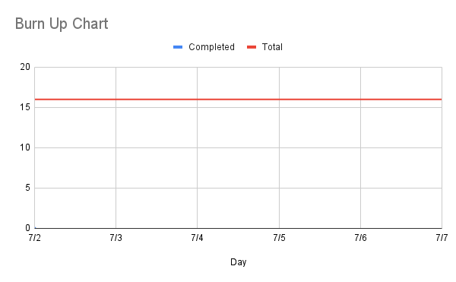

**Initial Scrum Board:**

Hosted on Trello: https://trello.com/b/alEVMUhs/agile-task-board

**Scrum Times:**

1. Monday, July 3rd 2023: 5:00 PM (In-Person)
2. Wednesday, July 5th 2023: 6:00 PM (Hybrid)
3. Friday, July 7th 2023: 5:00 PM (Online)